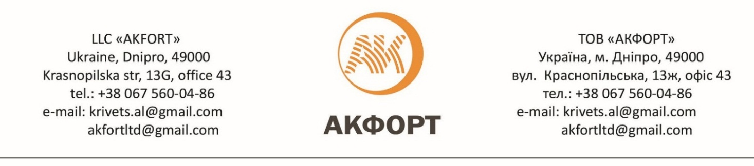
Our company offers a partnership for wholesale agricultural products produced in Ukraine. One of the prerequisites for cooperation with our Company is the absence of export restrictions, which ensures the stability of supply under previously agreed terms.
No | Product | Customs code | Grade/characteristics | Package | Unit | FCA-Ukraine, USD | DAP -Hrubieszów,USD
1 | Sunflower-seed oil refined, deodorized | 151211 | Grade R, DSTU 4492: 2005 Iodine value gJ2 / 100 g - 125-145; Weight content of non-pollinated substances (at most) - 1.0%; Nutrition value (per 100 g of product) - 99.9%; Caloric value per 100 g of product - 899 kcal. (3,761 kJ). | Plastic bottle 1 L | Pieces | 0,85 | -
2 | Sunflower-seed oil refined, deodorized | 151211 | Grade R, DSTU 4492: 2005 Iodine value gJ2 / 100 g - 125-145; Weight content of non-pollinated substances (at most) - 1.0%; Nutrition value (per 100 g of product) - 99.9%; Caloric value per 100 g of product - 899 kcal. (3,761 kJ). | Plastic bottle 5 L | Pieces | 4,25 | -
3 | Sunflower-seed oil refined, deodorized | 151211 | Grade R, DSTU 4492: 2005 Iodine value gJ2 / 100 g - 125-145; Weight content of non-pollinated substances (at most) - 1.0%; Nutrition value (per 100 g of product) - 99.9%; Caloric value per 100 g of product - 899 kcal. (3,761 kJ). | Flexitank 28900 L | Tons | 720 | -
4 | Non-refined sunflower-seed oil, I Grade | 151211 | Grade R, DSTU 4492: 2005: Colour value, iodine, not more than 25 mg; Acid-degree value, not more than 4 mg KOH/g; Peroxide value, not more than 7.0 ½ mmol/kg; Weight content of phosphorus-containing substances, not more than 0.6%; | Flexitank 28900 L | Tons | 720 | -
5 | Wheat flour top grade | 110100 | Wheat flour premium grade (Т-500):  moisture - max 14.5%  total Ash - max 0.55%  protein – 11% оn DM base (N*5,7)  wet gluten - min 26%(ISO)  falling number - min 250 | 50 kg polypropylene bags | Metric ton | 230,00 | -
6 | Wheat flour first grade | 110100 | Wheat flour first grade (Т-750):  moisture - max 14.5%  total Ash - max 0.75%  protein – 11% оn DM base (N*5,7)  wet gluten - min 27%(ISO)  falling number - min 250 | 50 kg polypropylene bags | Metric ton | 220,00 | -
7 | Granular Sunflower Meal | 230630 | Protein: min 35% max 38%  Fiber: min 18% max 20%  Humidity: min 11% max 12% | In bulk | Tons | - | 250,00
8 | Non Granular Sunflower Meal | 230630 | Protein: min 35% max 38%  Fiber: min 18% max 20%  Humidity: min 11% max 12% | In bulk | Tons | - | 250,00
9 | Rapeseed oil | 151411 | Please check availability.
10 | Rapeseed meal | 230641 | Please check availability.

In order to establish a long-term and mutually fruitful partnership, we kindly ask you to inform us of the need for additional information and to ask any questions.
Moreover, we are open for a productive dialogue and are ready to consider all the counteroffers and additional conditions of cooperation.
Contact person:
Lavrinenko Dmitrii,
instant messengers: +380508645195 (Messenger, WhatsApp, Telegram, Viber, Signal)
tel: +380685606215;,
e-mail: dmitryi.lavrinenko13@ukr.net; dmitriy.lavrinenko13@gmail.com

